GILGANDRA HIGH SCHOOL

Uniform Price List

All items of uniform can be purchased from the P&C Association via the school office.

School Shirts $25 Sports Shirts $25
Shorts $25 Sloppy Joes $35
Navy Skirts $55 Knitted Jumpers $55
School Jacket $65 Trackpants $45 and $25

A Reminder about School Footwear

These styles of shoes are ACCEPTABLE FOOTWEAR

The school expects students to follow Department of Education and Training Policy and the OHS Act 2000 by wearing enclosed leather, lace-up, buckle or Velcro fastened shoes. They must cover the whole top of the foot and have a low heel.
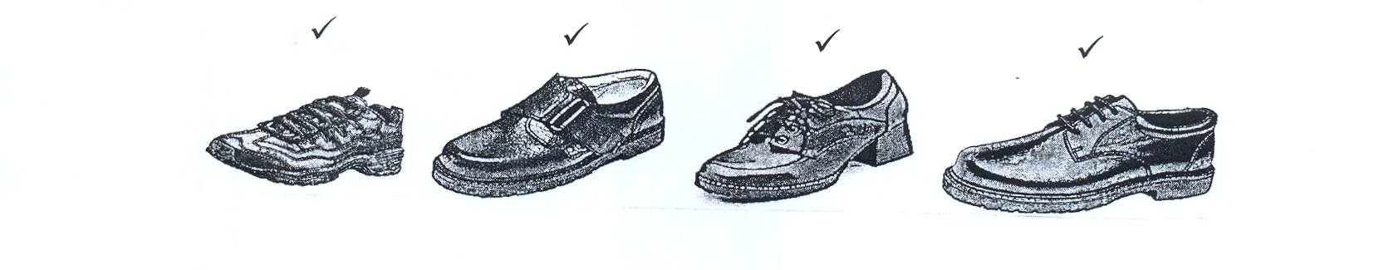

These styles of shoes are UNACCEPTABLE FOOTWEAR

Students must not wear skate shoes, black soft ballet style shoes, open top Mary-Jane shoes, canvas or similar material type shoes. If you are not sure what footwear is acceptable then please consult the school before buying new shoes.
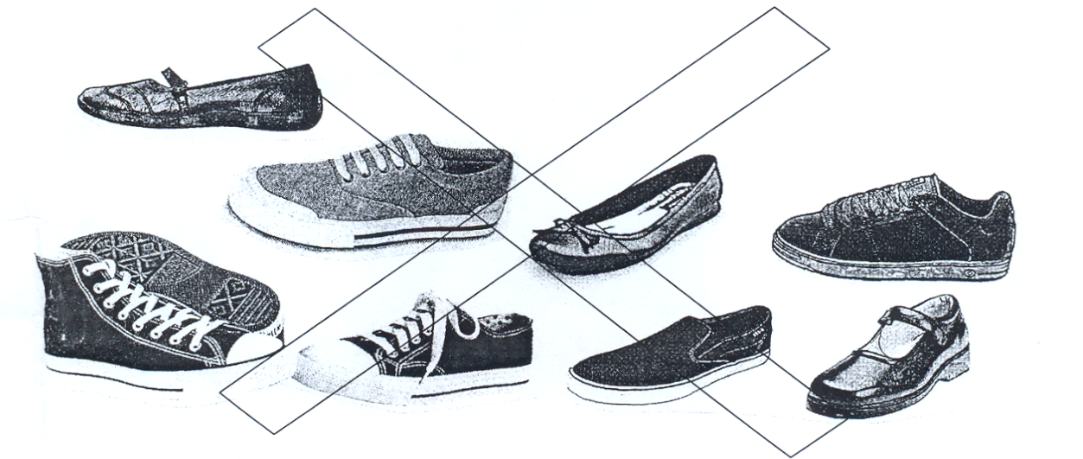

NB: Shoes must be of a firm leather type to satisfy safety requirements. Failure to wear this type of shoes may result in temporary exclusion from a practical subject.

Parents/carers may request support for the cost/provision of uniform items by discussing the matter with the Principal.

The Principal should be contacted for any clarification on the uniform policy.

